**MS SQL SERVER**

**Standard Operating Procedures**

**(SOP)**

**MS SQL Server 2014 Failover Cluster Installation**

Submitted to



**By**



CIS, Wipro Limited

Document Details

|  |  |
| --- | --- |
| Project Name | Innogy SE |
| Account | CIS |
| IT Component/Application Title | MS SQL Server 2014 Failover Cluster Installation. |
| Current Version | 1.2 |
| List of Contributors | Pradipkumar Kansara, Kiran Bhalekar, Ayushi Gautam, Sivakumar Goud, Pramod Patil |
| Customer Contact Information |  |

Version History

(All revisions made to this document must be listed in chronological order. All revisions must be approved. Review and Approval can be done by an internal source or by the customer)

|  |  |  |  |  |  |
| --- | --- | --- | --- | --- | --- |
| Version | Date of Revision | Description | Author | Reviewed By | Approved By |
| 1.0 | 01-12-2017 | Initial Draft | Sivakumar Goud | Pradipkumar Kansara | Santosh Badiger |
| 1.1 | 06-12-2017 | Document Submitted | Sivakumar Goud | Pradipkumar Kansara | Santosh Badiger |
| 1.2 | 22-11-2018 | Updated the content | Pramod Patil | Pradipkumar Kansara | Santosh Badiger |

Document Distribution List

|  |  |  |
| --- | --- | --- |
| **Sr.No** | **Name and Company** | **Purpose** |
| 1 | RWEIT-SQLDBA | Document is help full for Installing SQL server 2014 failover cluster. |

**Table of Contents**

1. Purpose…………………………………………………………………………………4

2. Scope…………………………………………………………………………………………….4

3. Introduction/overview………………………………………………………………….4

4. Detailed procedure………………………………………………………………5-30

**1. Purpose**

This document is prepared for the concept of SQL Server Failover Clustering 2014 in SQL Server database administration services.

**2. Scope**

Document is prepared for SQL Wipro sustenance team and provide the concept of Ms SQL Server Failover clustering.

**3. Introduction/Overview**

SQL Server failover clusters are made of group of servers that run cluster enabled applications in a special way to minimize downtime. A failover is a process that happens if one node crashes, or becomes unavailable and the other one takes over and restarts the application automatically without human intervention

**4. Detailed procedure**

**Installation of SQL Server 2014 on a**

**New Failover Cluster**

**Step 1:** Go to the SQL Server setup file location. Right click on setup.exe and choose "Run as administrator". The SQL Server Installation Centre will appear on your screen as shown in the screenshot below. Select the "Installation" tab from the left pane and click on "New SQL Server failover cluster installation" from the right pane.

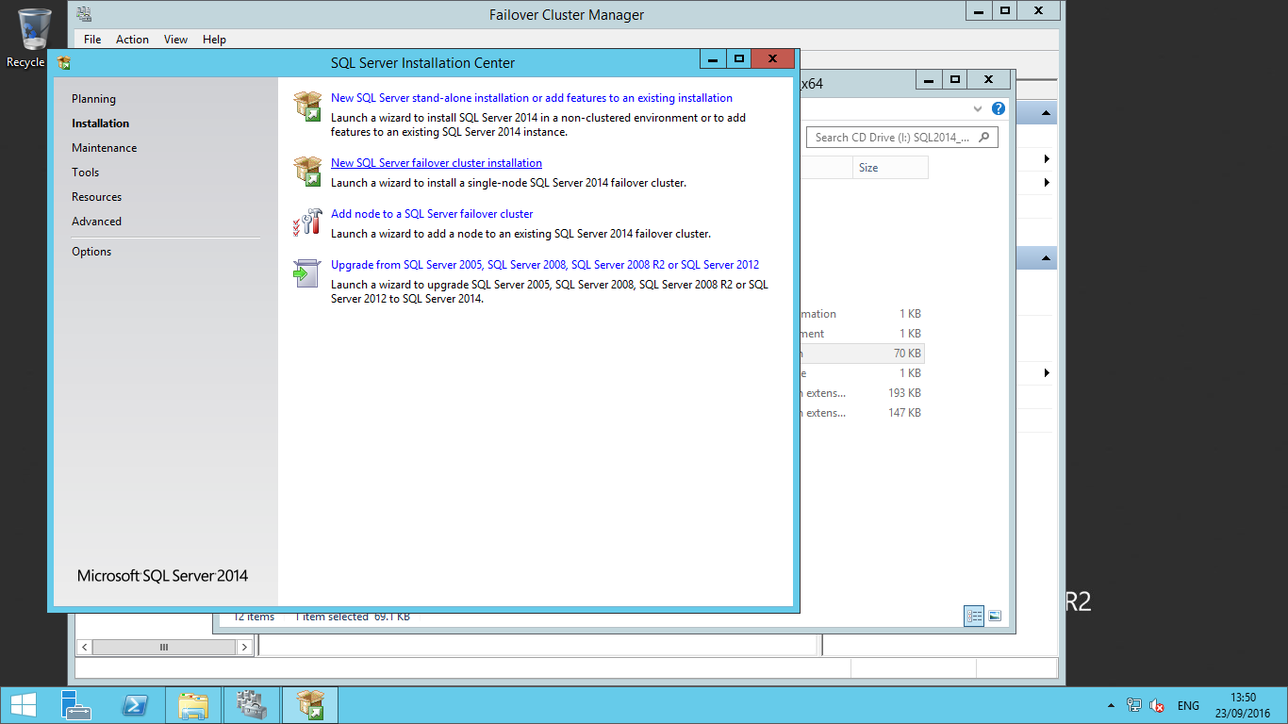

**Step 2:** Once you click on "New SQL Server failover cluster installation", the SQL Server installation window will appear and it will ask you to enter your product key for SQL Server. Enter the key or if it is an evaluation version choose the first option. Sometimes the product key option will be greyed out, so in that case you can just click the Next button.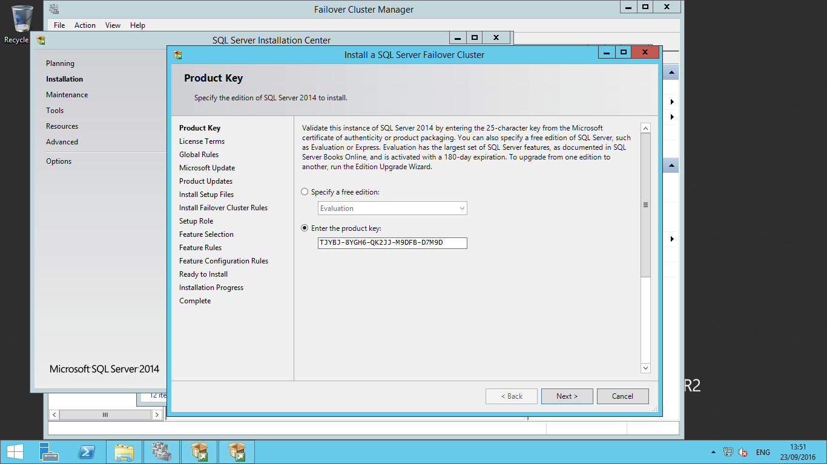

Once you click on Next, another window will load and ask you to click on the check box to accept the license terms and conditions for the SQL Server product. Click on the Next button after accepting the license terms.

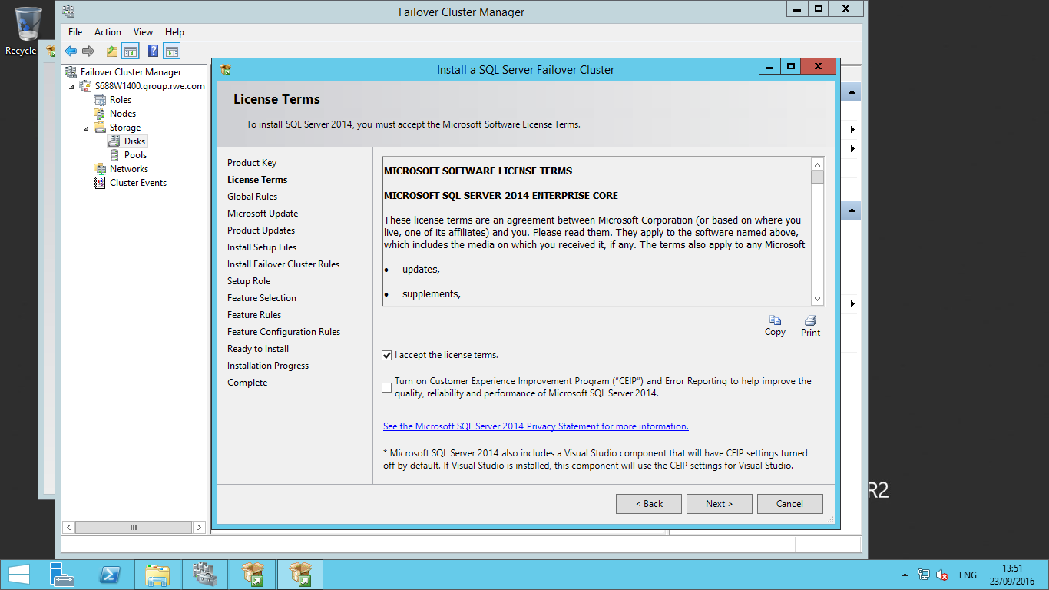

**Step 3:** After accepting the license terms, SQL Server will start checking the global rules and display the status of all the rules. If any rule fails, setup will not proceed further and you need to first fix the issue. You can see below the rules are successful, so click on the Next button to proceed.

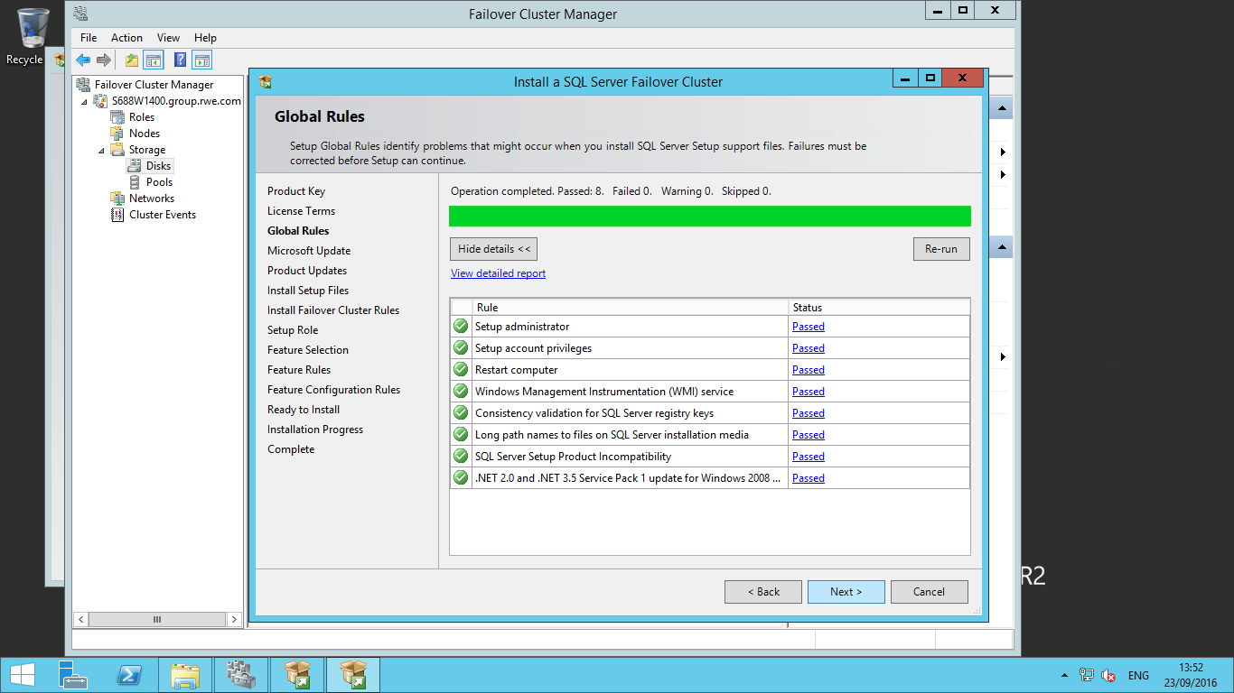

**Step 4:** The next window will ask you to check for Microsoft Updates for Windows and SQL Server 2014. If you want to check for updates from Microsoft you can click on the check box in the below screenshot.

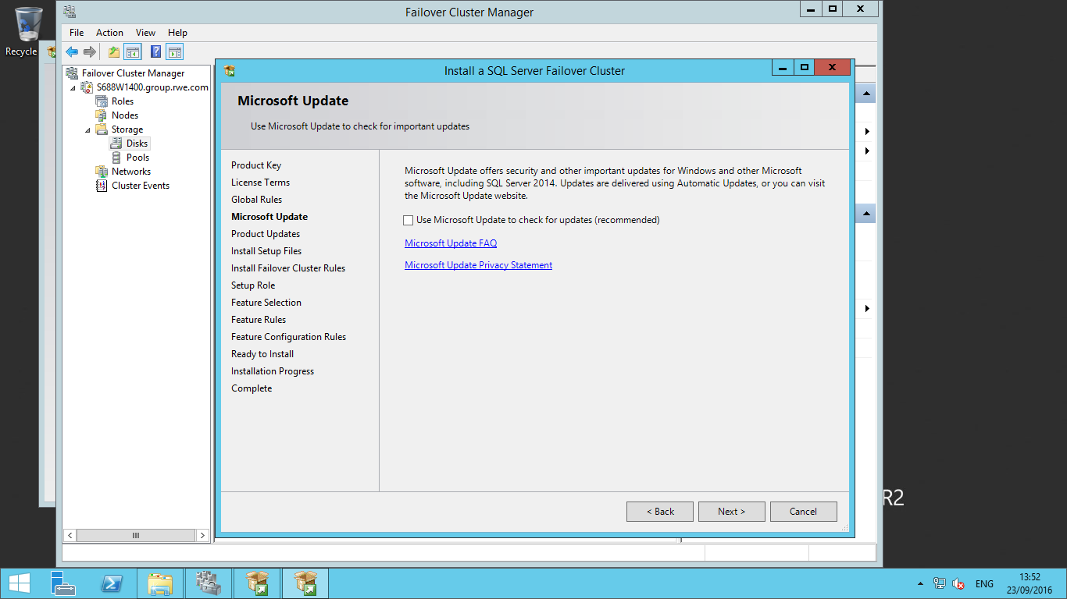

Once you click on the Next button of the above screen, the Product Update window will appear. Click on Next button.

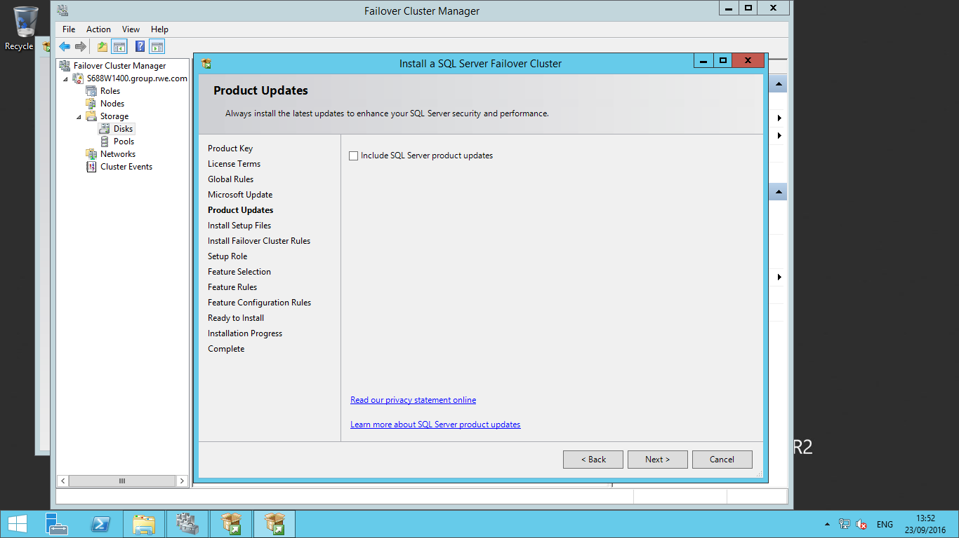

Then it will redirect to Install Set Up Files window. Click next Button.

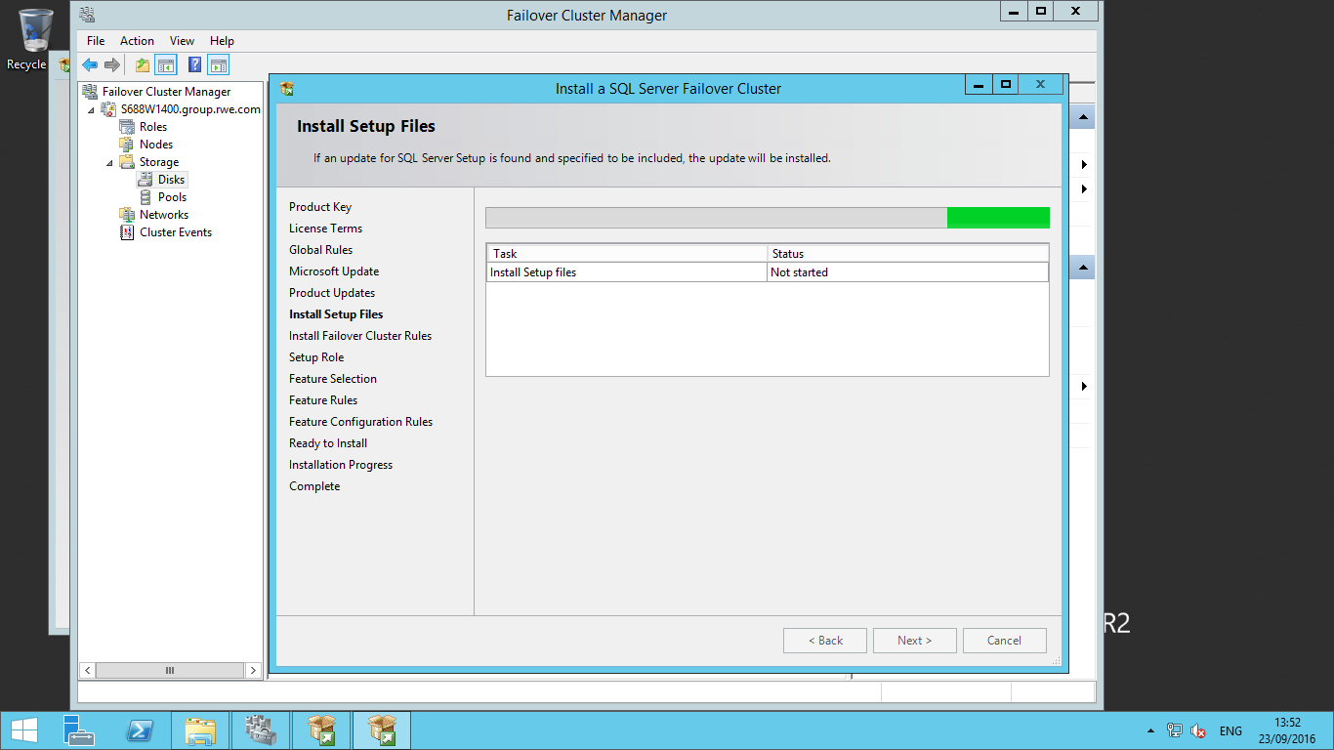

**Step 5:** The next window will check failover cluster rules. We can see all rules have been checked with both successful and warning results. We can skip warnings at this point in time as we can fix them post installation. Click on the Next button to proceed with the installation.

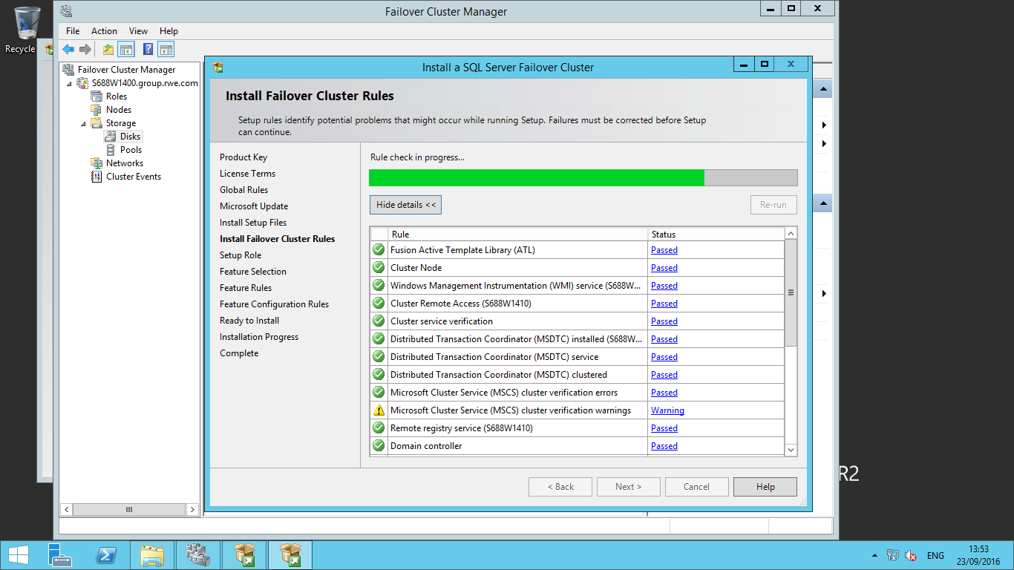

Below screen shows all the Rules are complete successfully except two Warnings. We can avoid these Warnings.

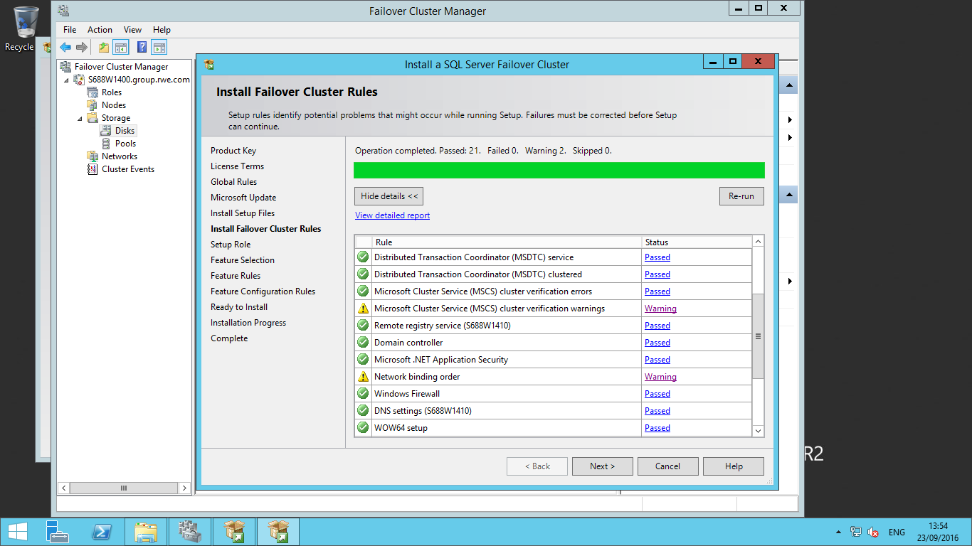

**Step 6:** The next interface is the setup role window, where you choose the installation features. You will find two options on this page. One is to configure SQL Server feature installation and another is to configure SQL Server PowerPivot for SharePoint. Once you choose your setup role, click on the Next button.

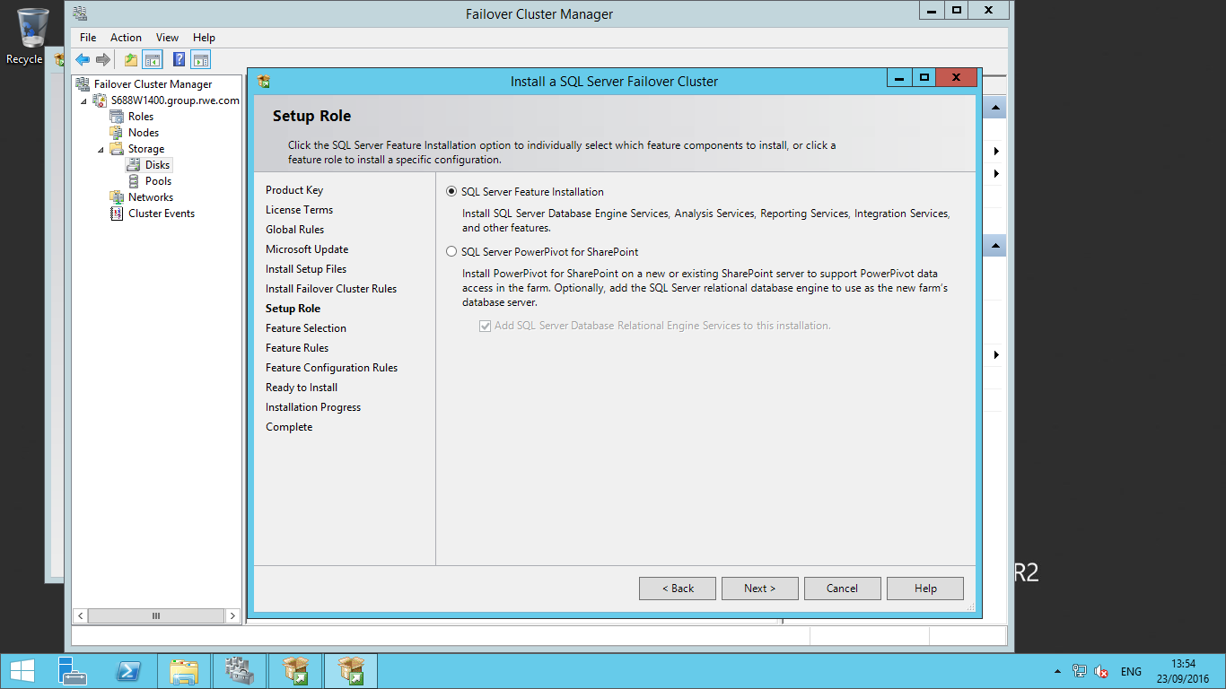

**Step 7:** The next step in the process is for feature selection. Choose the features you want to install on your cluster server. Do not select all features if you will not use them, as this will use server resources that could be used by the SQL Server database engine or Windows. 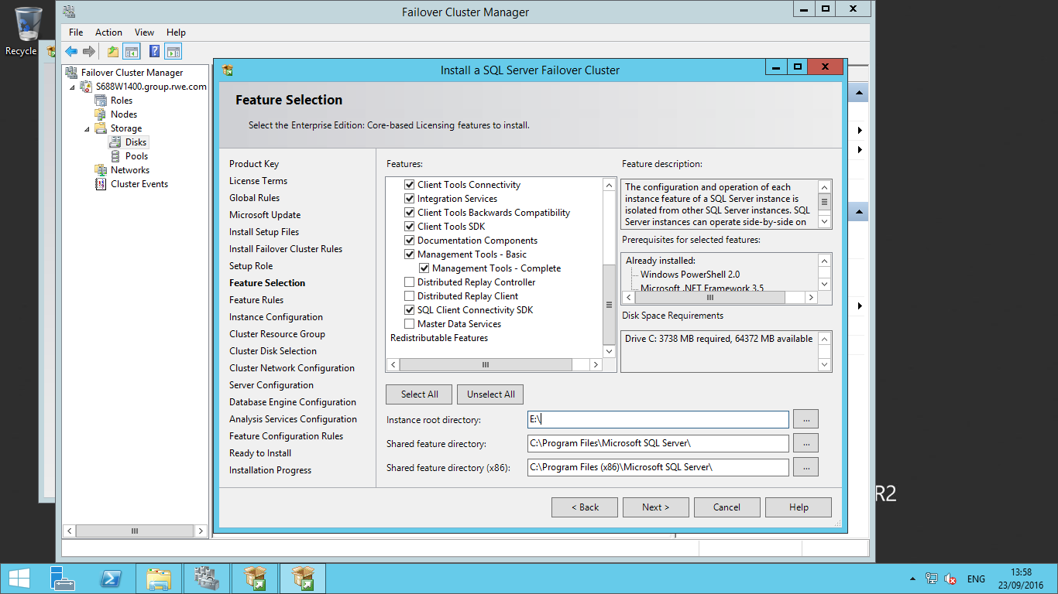

I have selected the SQL Server Database Engine along with a few shared features as shown in the below screenshot. You can also change the root directory for each of the selected features and for the SQL Server binaries. Click the Next button after selecting the features you want to install. Another window will check the feature rules.

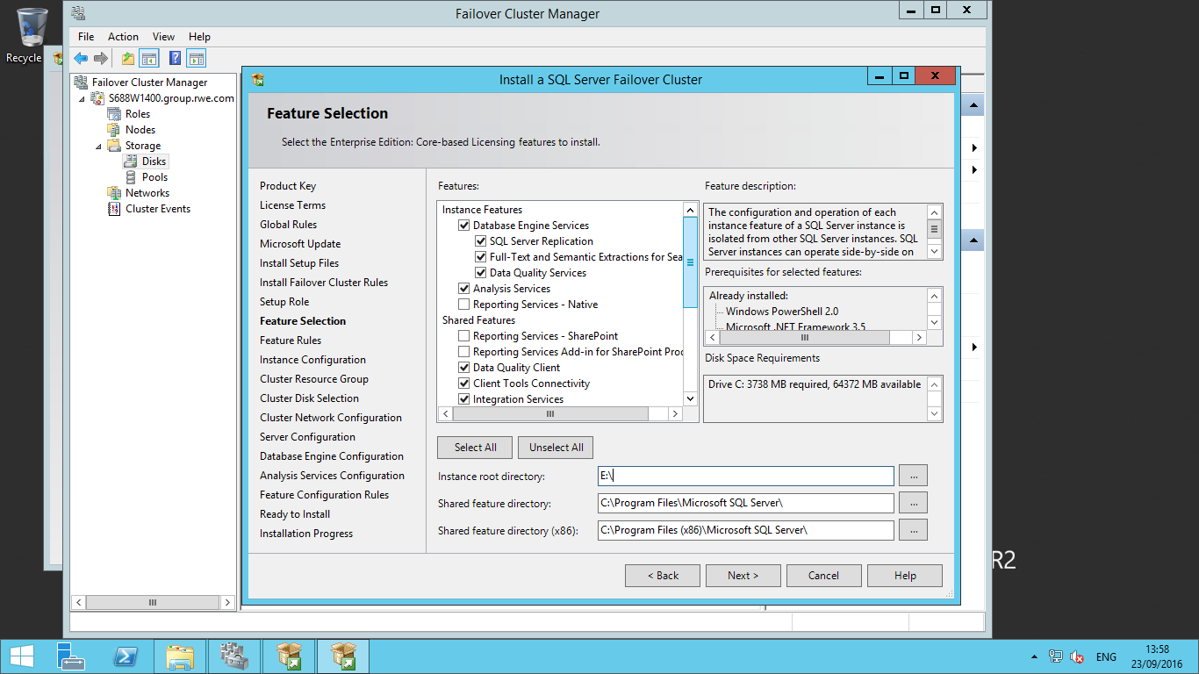

Once every rule is checked, you can proceed again by clicking on the Next button.

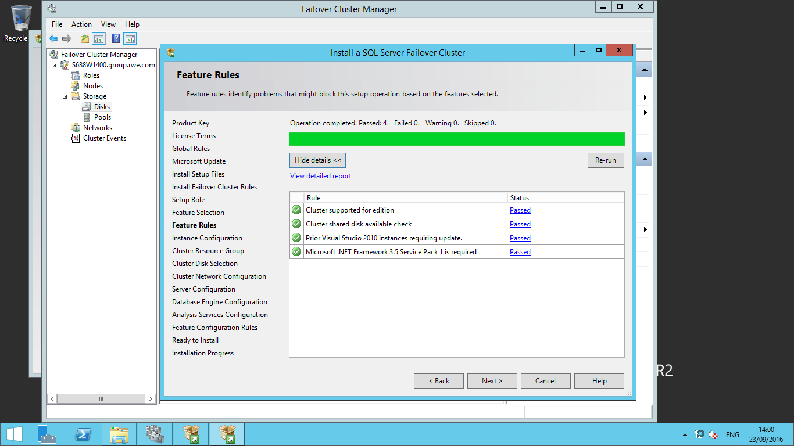

**Step 8:** Our next interface is the Instance Configuration window. This is an important step because in this step you enter the SQL Server Network Name along with the Instance ID. Now click on the Next button to go to the next window.

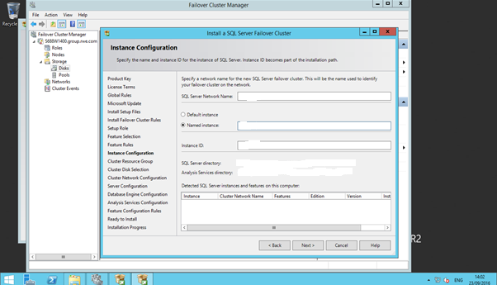

It will create the SQL Server Network Name and Named instance.

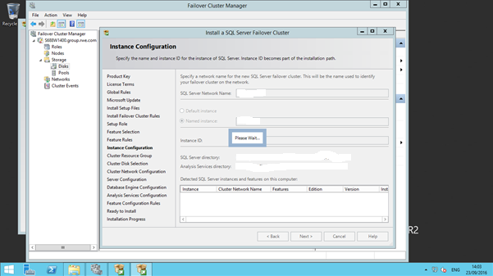

**Step 9:** Next window is for **cluster resource group**. You can change the cluster resource group name.

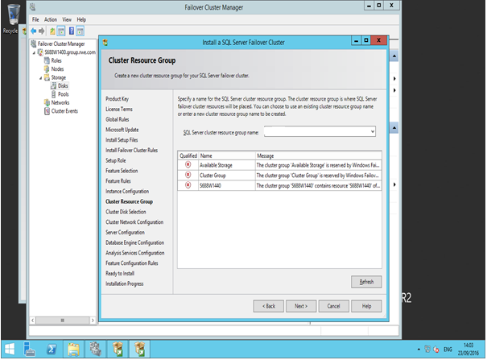

**Step 10:** The Cluster Disk Selection window is where you will see the list of all shared disks that you can include in the SQL Server cluster resource group. We need to select all three shared disks and clicked on the Next button to proceed. If you have multiple shared disks, make sure to select only those that will be part of this cluster.

We can’t select cluster disk 1 and cluster disk 5. As Cluster disk1 is for **Quorum** and Cluster disk5 is for **MSDTC**.

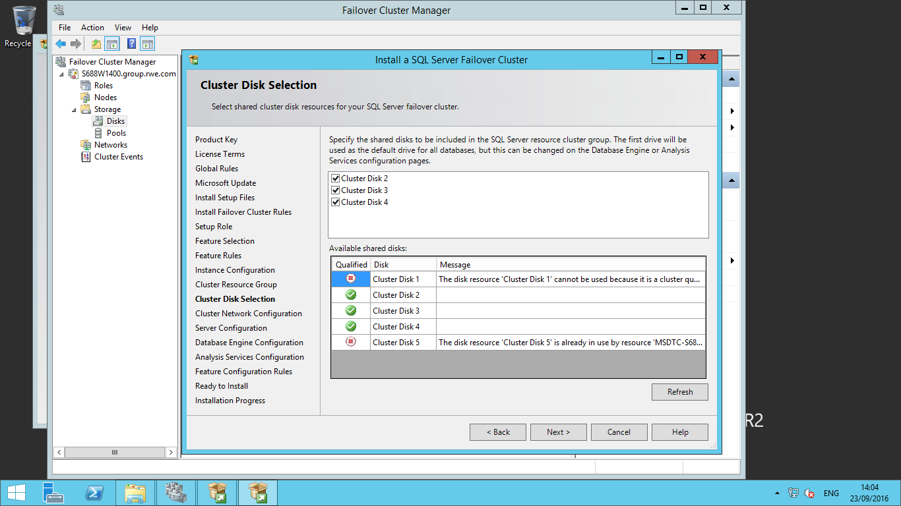

**Step 11:** Next window is to configure the cluster network. Here you need to enter your unique and unused IP address in the address column as shown in below screenshot. Enter the IP address and click on the Next button.

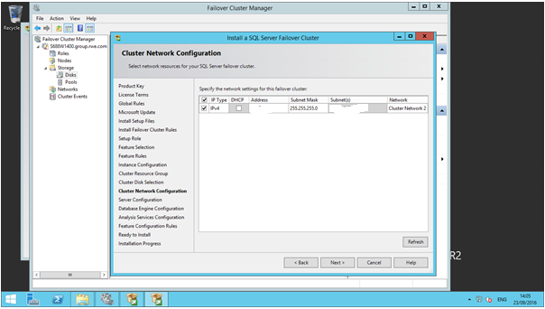

**Step 12:** Once you click next in the above step, it will ask you to enter the SQL Server service accounts and their passwords to run the SQL Server services. We should use one service account, for SQL Server and SQL Server agent. Enter the credentials and click on the Next button to go to the database engine configuration page.

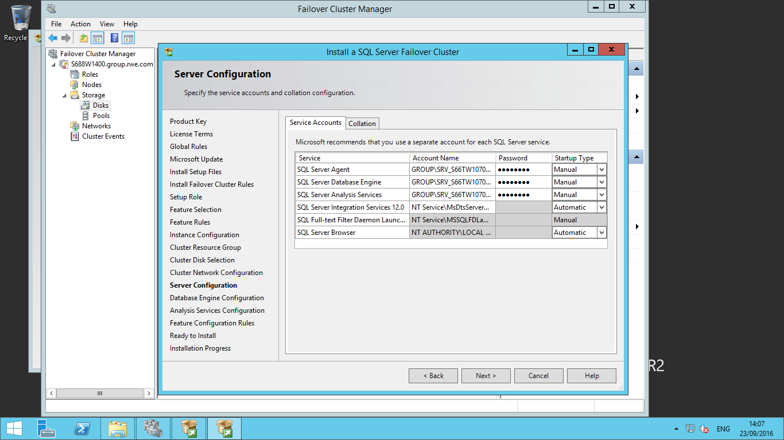

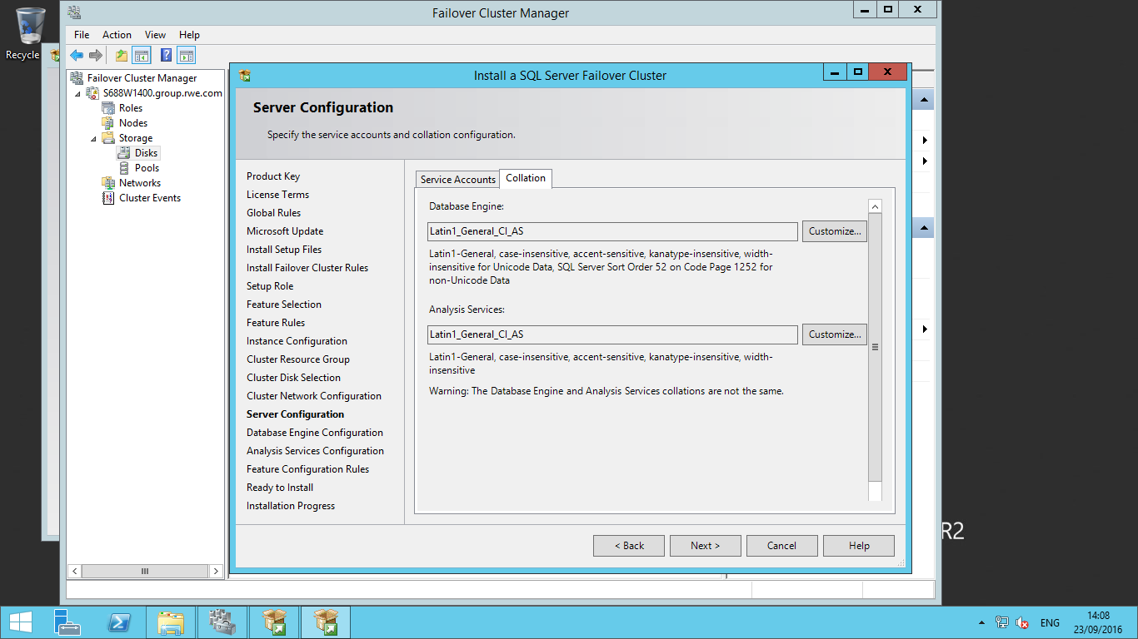

**Step 13:** Next window is very important and here setup will ask you to configure the SQL Server database engine. There are three tabs in this window. First is 'Server Configuration', second is 'Data Directories' and third is 'FILESTREAM'. We will start configuring with the first tab that is server configuration. The below screenshot explains this window. We need to select the authentication mode of the SQL Server. Now we are going with Mixed mode authentication. Now click on "**Add Current User**" to add yourself as an administrator on SQL Server. You can add other accounts as well which should be admins in SQL Server.

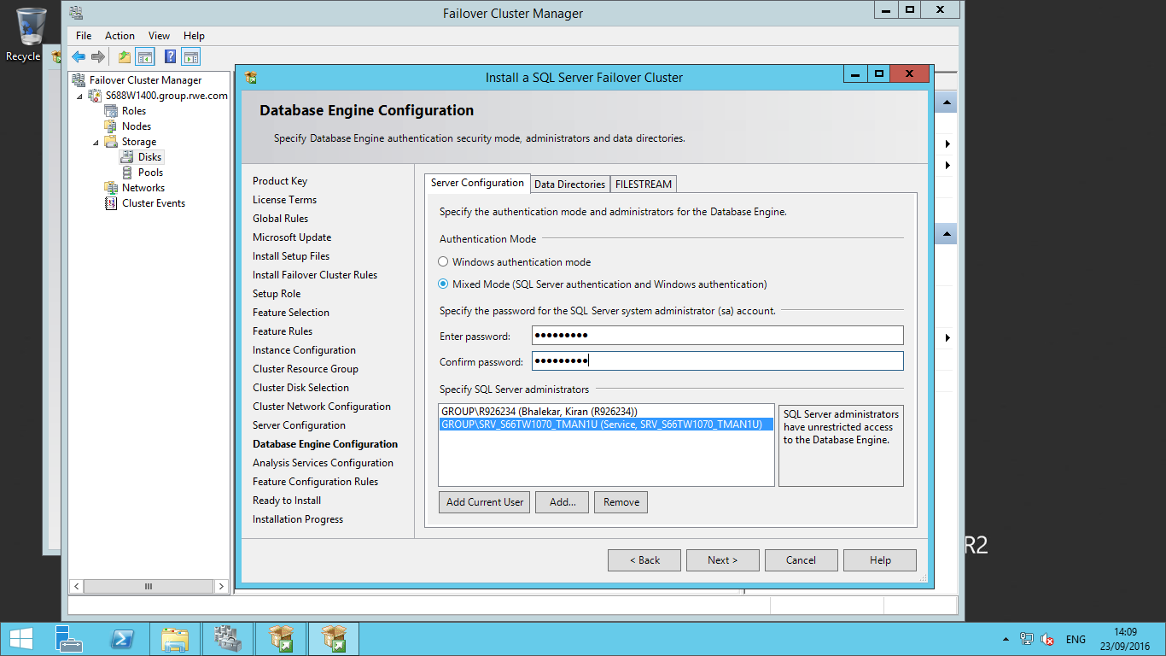

Now click on "**Data Directories**" to configure the data directories where the system and user databases along with backup files will be placed. Here we have to provide Data, Log, Temp and Backup directories.

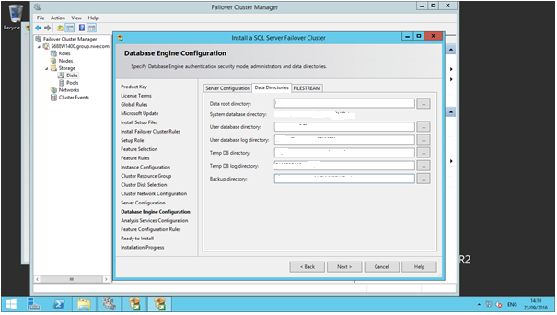

Below is the screen for the Analysis Services Configuration as we selected Analysis services at the time of Future selection step (step7). Add the user for Analysis service and click next button.

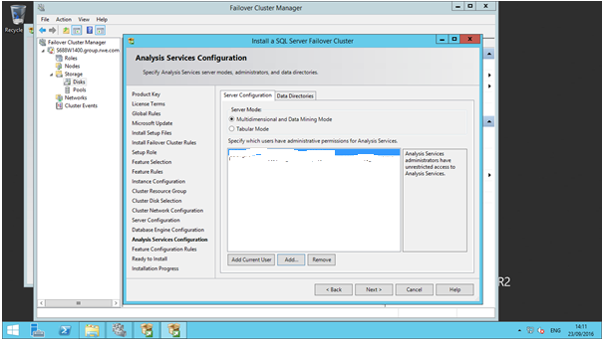

In analysis service configuration, We have to provide the right path for directories of Data, Log, Temp, Backup for Analysis services configuration. 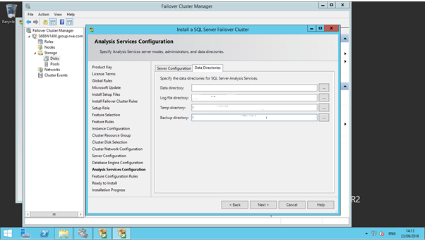

After complete with Analysis service configuration step. Click on Next to reach the final installation screen.

**Step 14:** Here you can check the features and configurations you have selected. You can also see the configuration File.

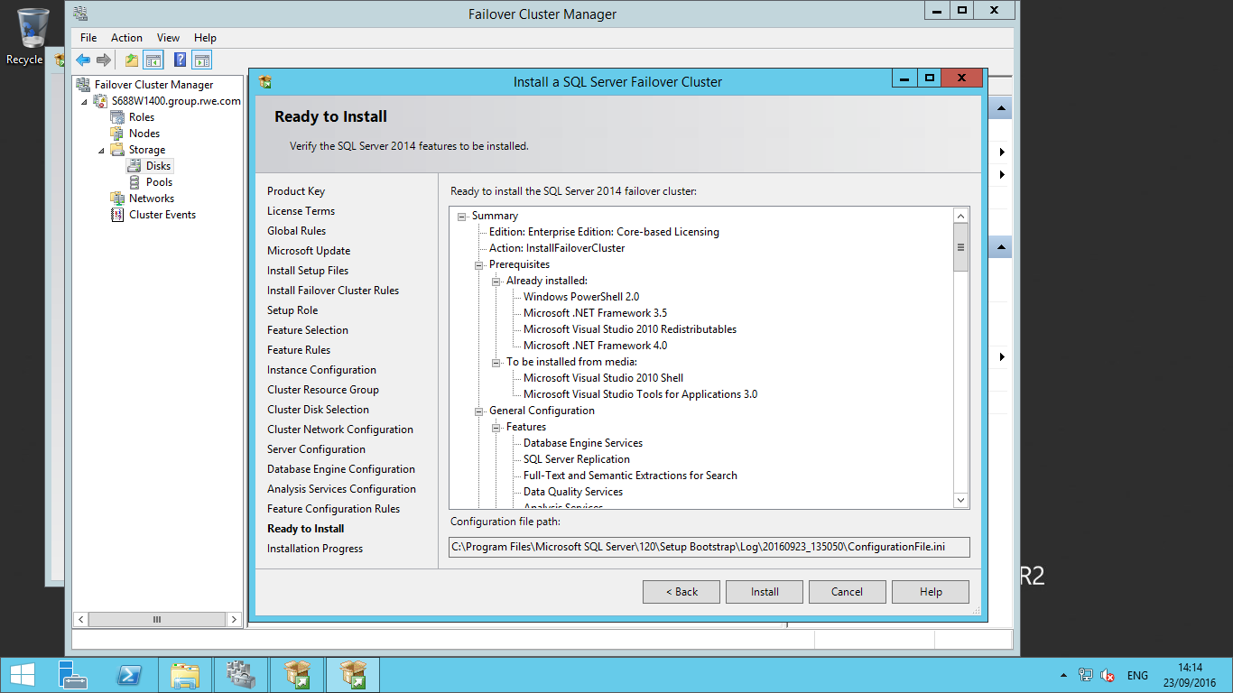

Now click on the Install button to start the installation process of SQL Server. You can see the installation is running based on the progress in the below screenshot.

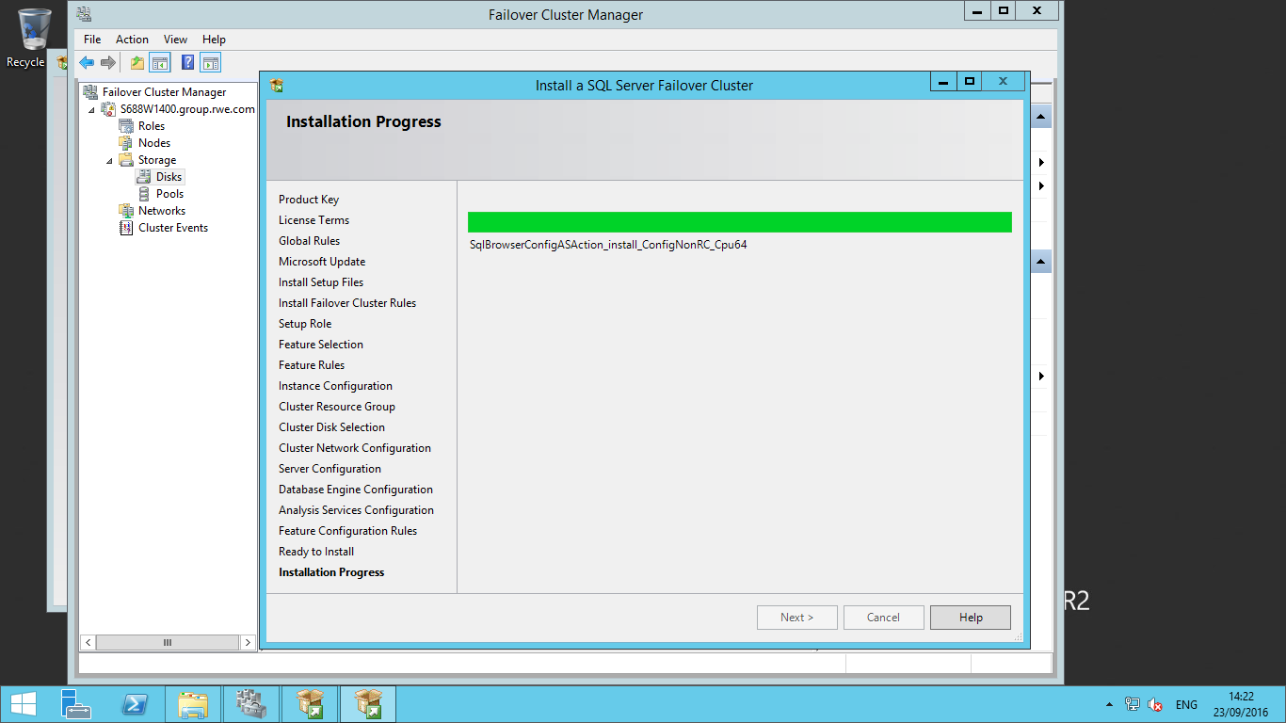

Once the installation successfully completes, you will get the below screen with confirmation that all the features you have selected are installed.

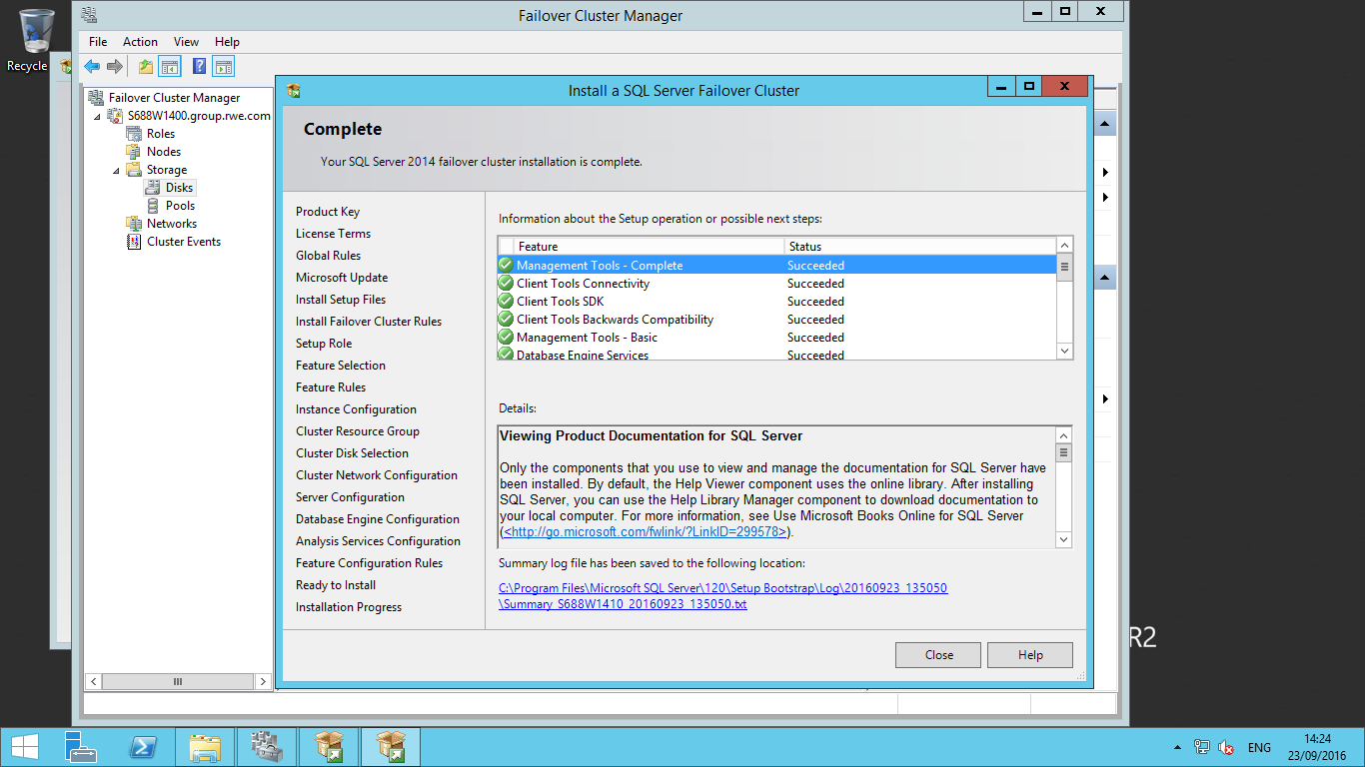

# Adding a New Node to a SQL Server

# 2014 Failover Cluster

# Step 1: On the new node where you want to install SQL Server, go to the SQL Server setup file location and right click on setup.exe and choose "Run as administrator". SQL Server Installation Center will appear on your screen as shown in the below screenshot. Select the "Installation" tab on the left side and click on the third option "Add node to a SQL Server failover cluster" from the right side.

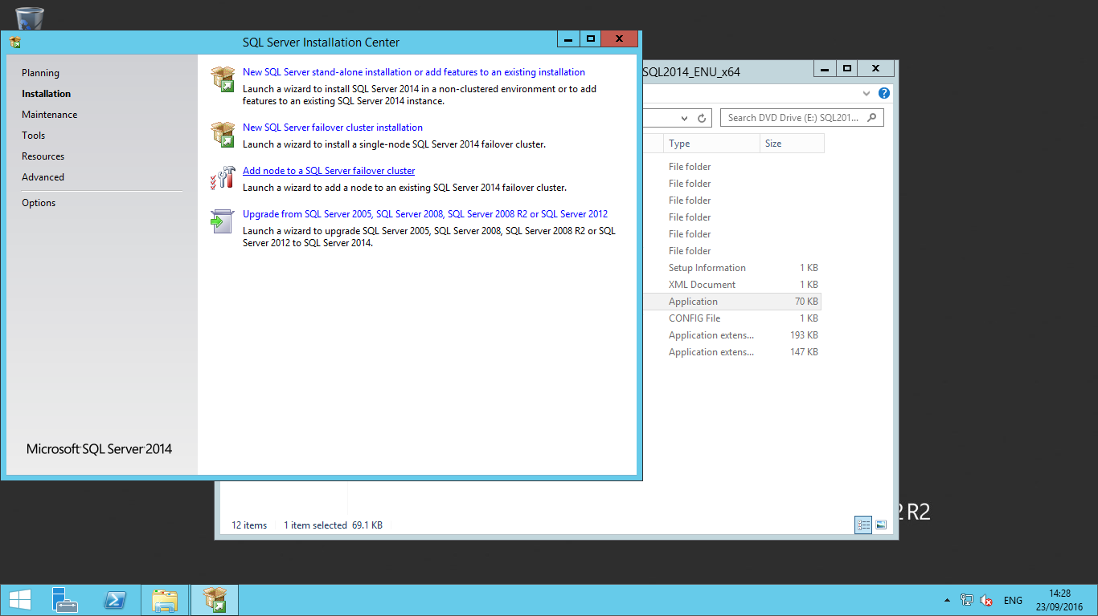

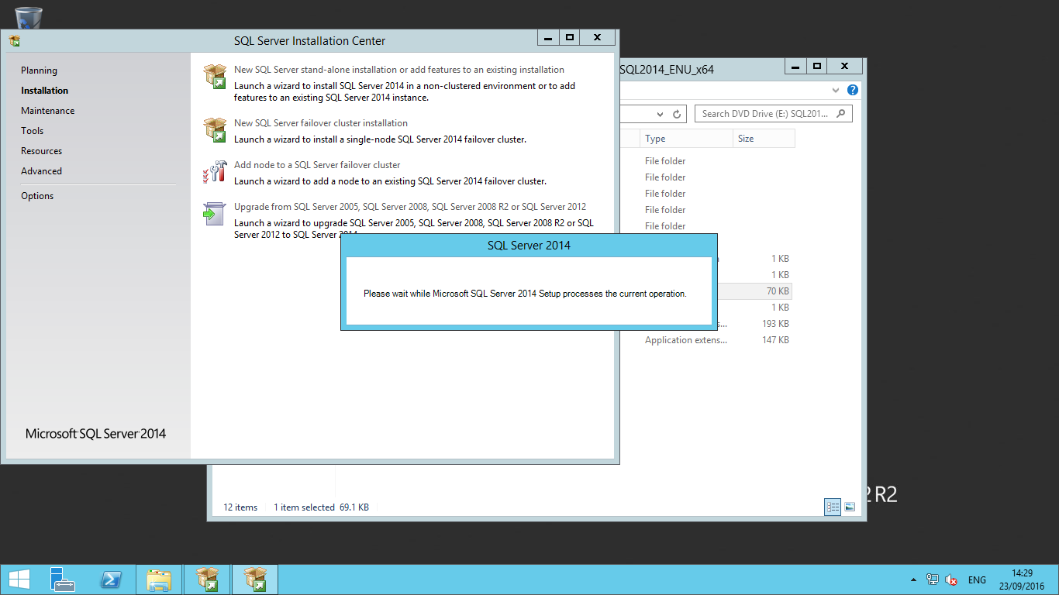

**Step 2:** Once you click on "**Add node to a SQL Server failover cluster** ", the SQL Server installation window will appear and it will ask you to enter your product key for SQL Server. Enter the key. Then you can just click the Next button.

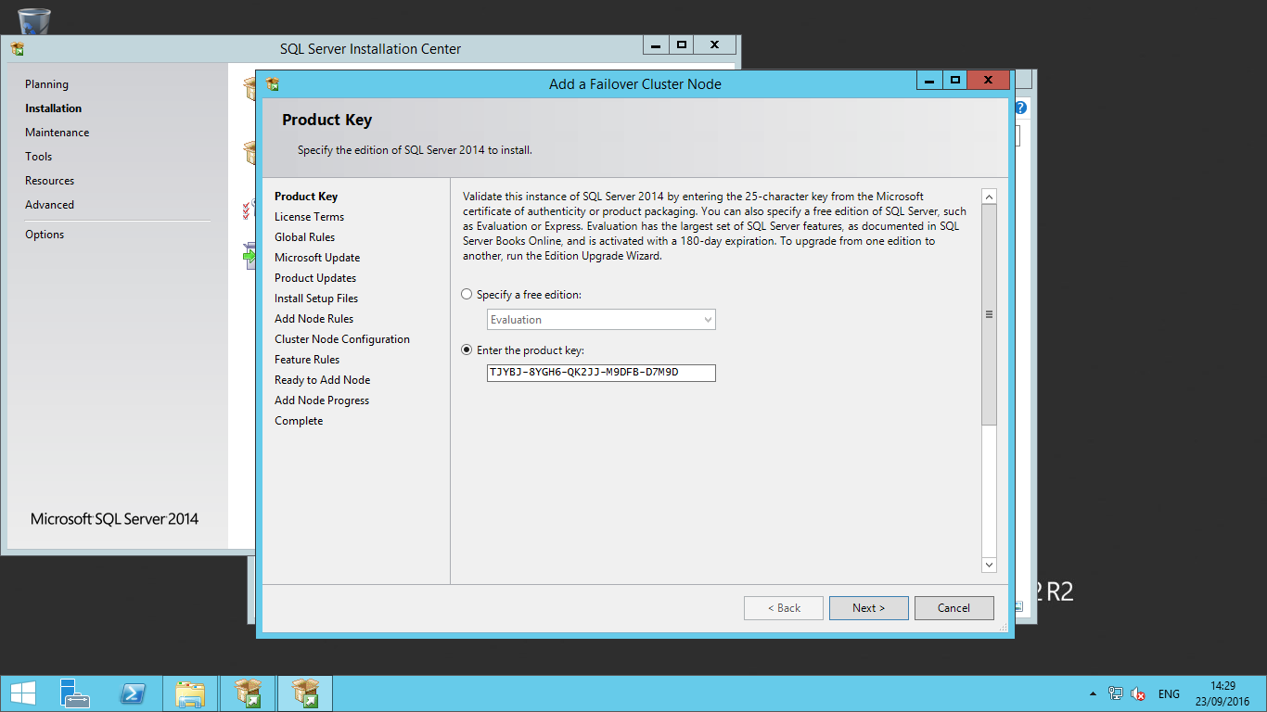

Once you click on Next, another window will load and ask you to click on the check box to accept the license terms and conditions for the SQL Server product. Click on the Next button after accepting the license terms.

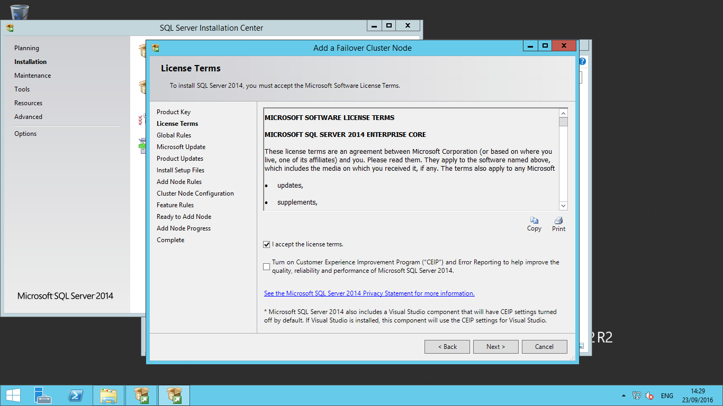

**Step 3:** After accepting the license terms, SQL Server will start checking the global rules and display the status of all the rules. If any rule fails, setup will not proceed further and you need to first fix the issue. You can see below the rules are successful, so click on the Next button to proceed.

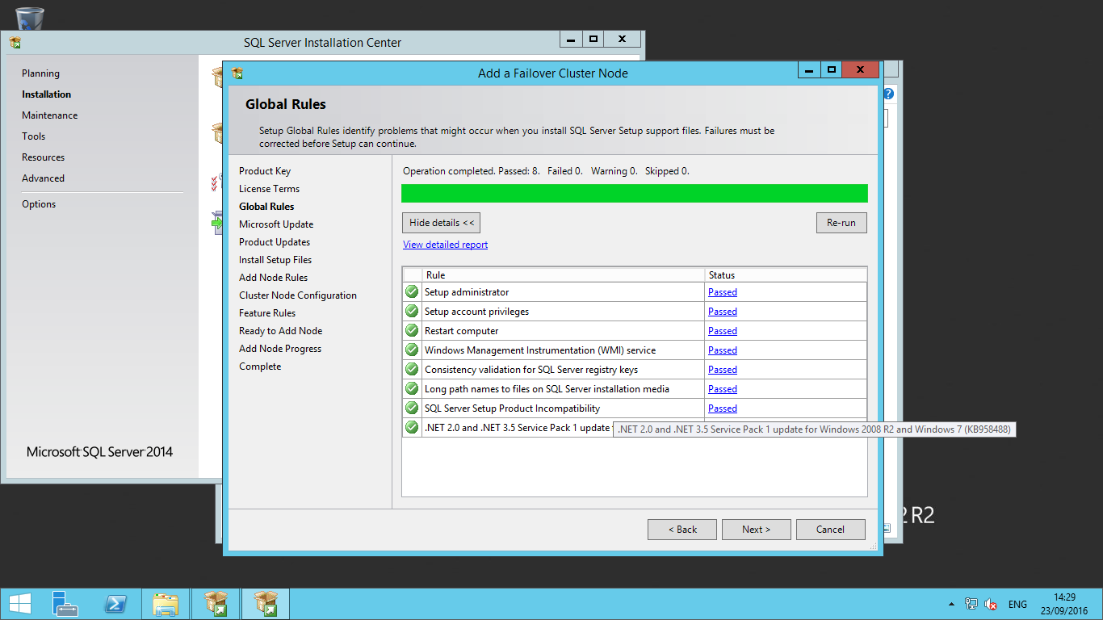

**Step 4:** The next window will ask you to check for Microsoft Updates for Windows and SQL Server 2014. I have not checked this option, but if you want to check for updates from Microsoft you can click on the check box in the below screenshot.

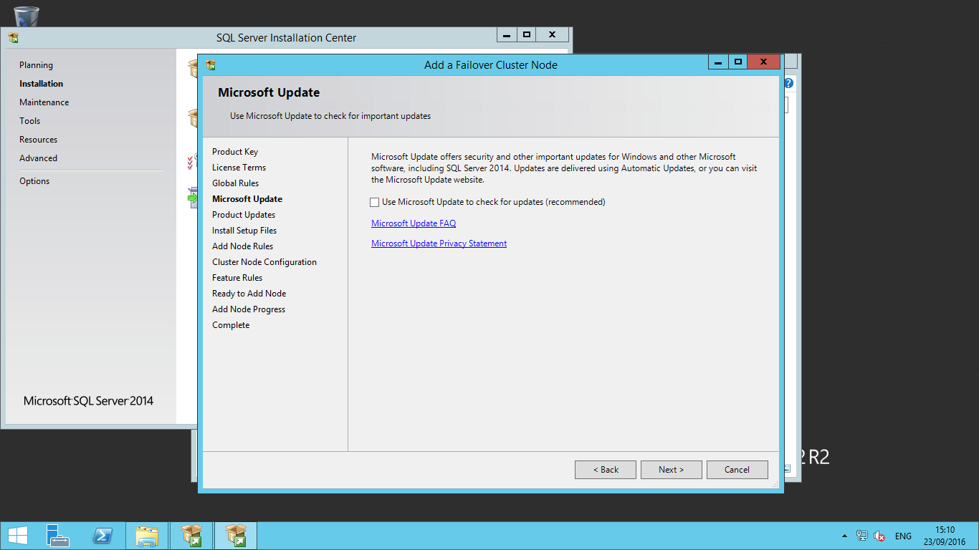

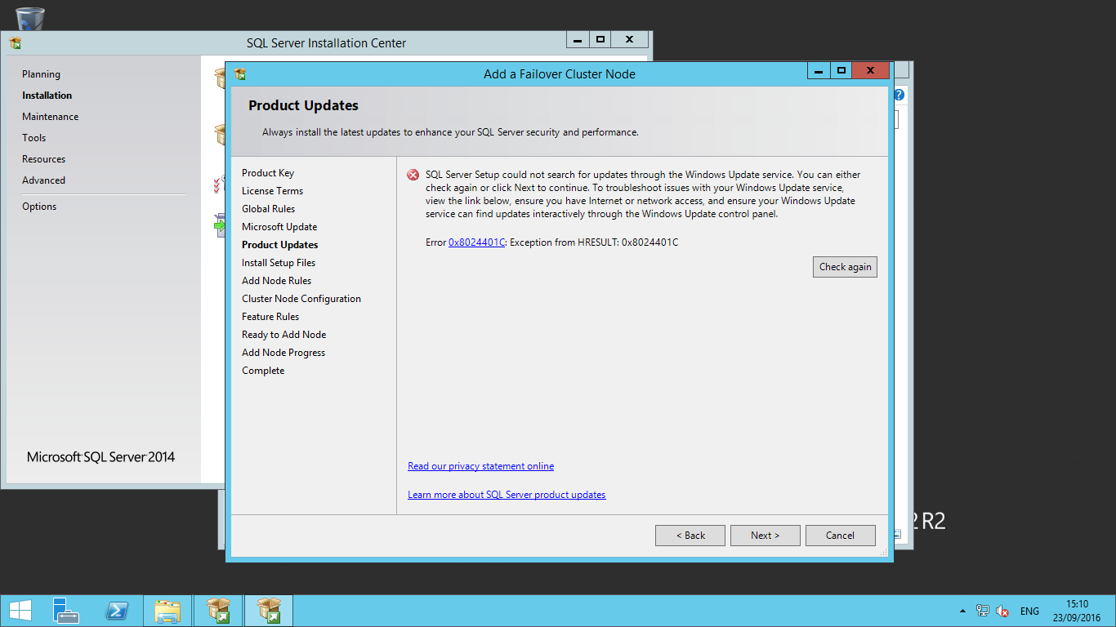

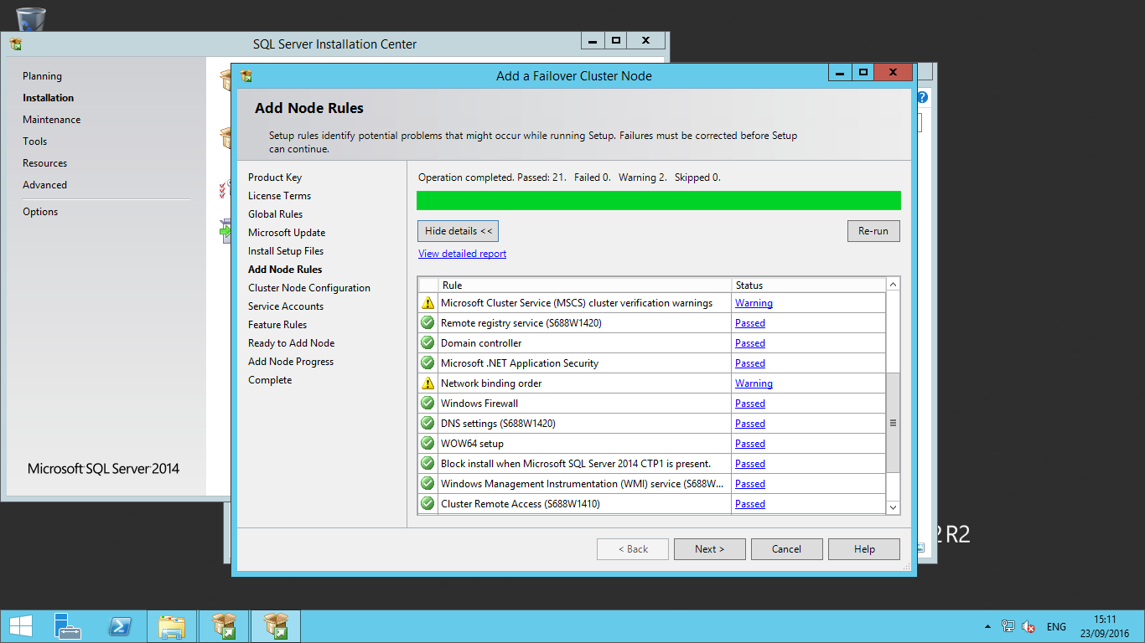

**Step 3:** Now SQL Server will ask you to **configure the node** to be added to the SQL Server failover cluster. The details about the SQL Server cluster instance which we have installed in our last tip will appear on the right. We can see the SQL Server cluster network name, Name of this Node . We can also see the features that have been installed on SQL-NODE1.

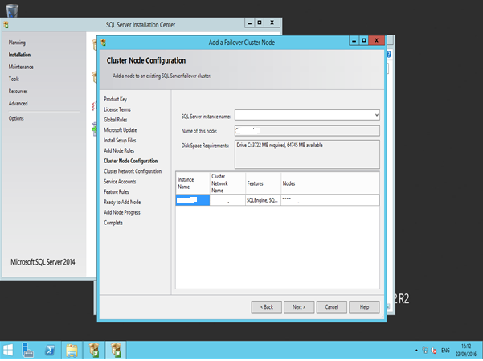

**Step 4:** Now click on the Next button to proceed with the installation. The next window will ask you to verify the cluster network configuration. We do not need to enter anything here, but just need to validate the details like the SQL Server virtual IP which we used to install the SQL Server cluster. It will be same as we entered during the SQL Server cluster installation. Click on the Next button to go on to the next window.

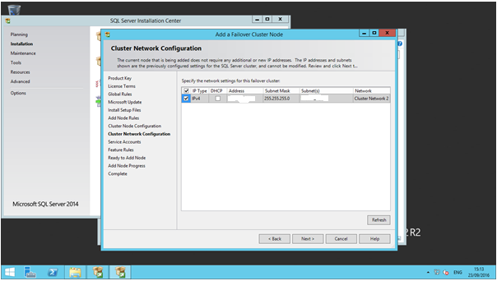

**Step 5:** The next window will ask you to configure the SQL Server service accounts. Enter the password of the service accounts and click on the Next button.

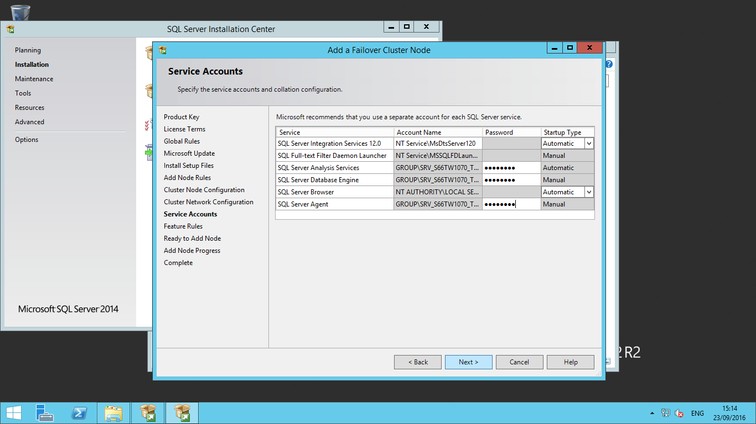

**Step6:** The next window will ask you to Feature Rules, it will check all features. Once successfully complete then we have to click on Next button.

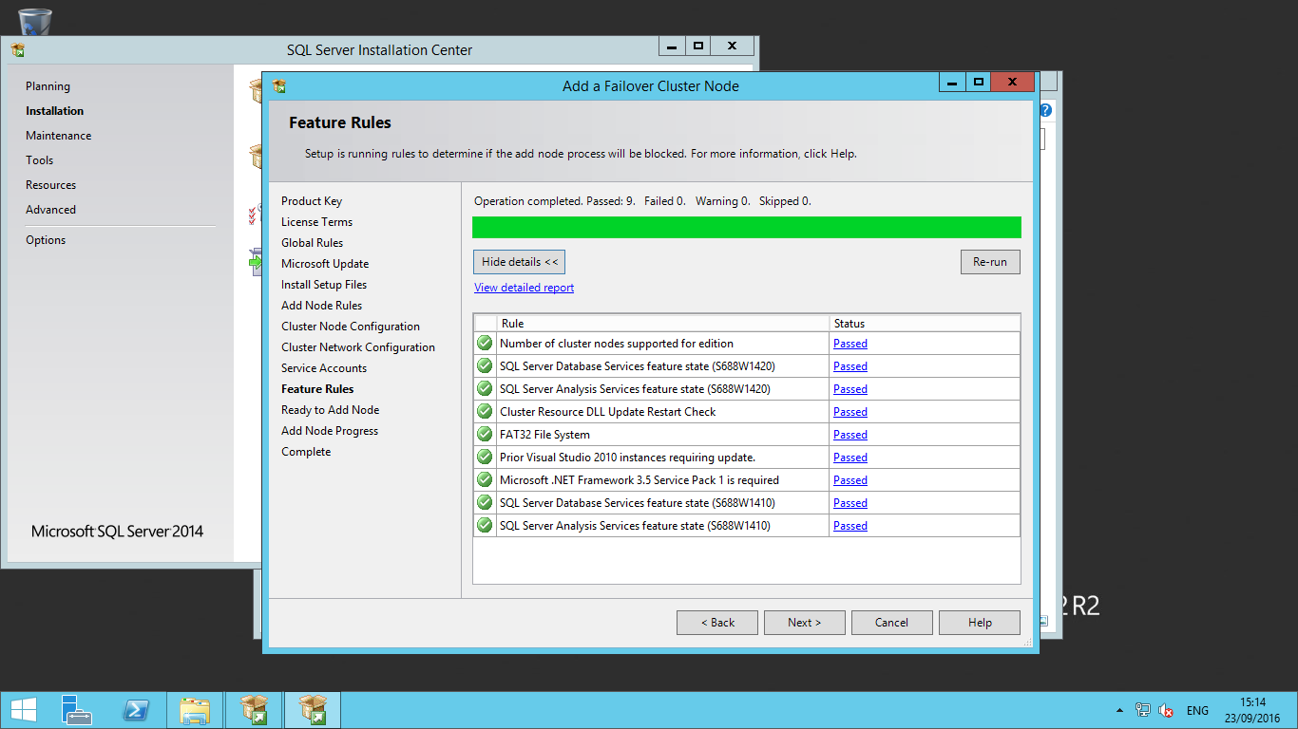

**Step 6:** The next window is the "Ready to Add Node" page to verify all the details as shown in the below screenshot.

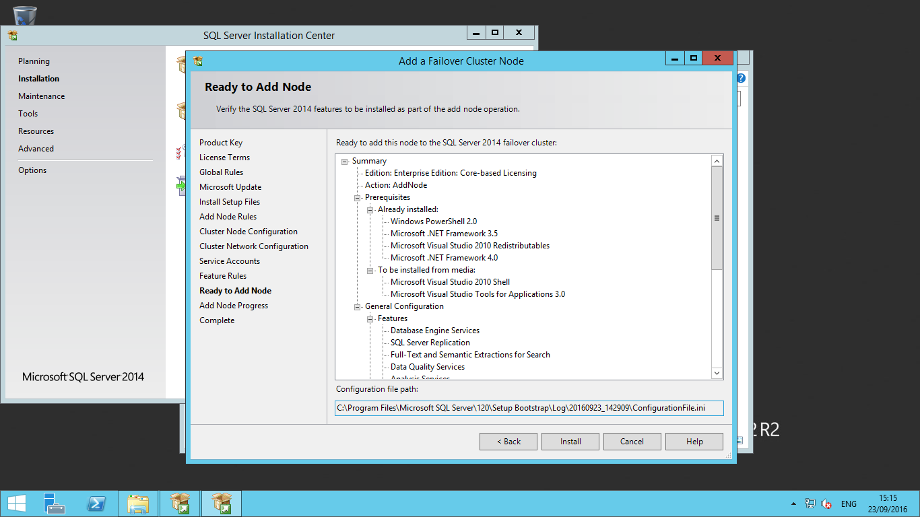

You can see the add node progress in the below screenshot.

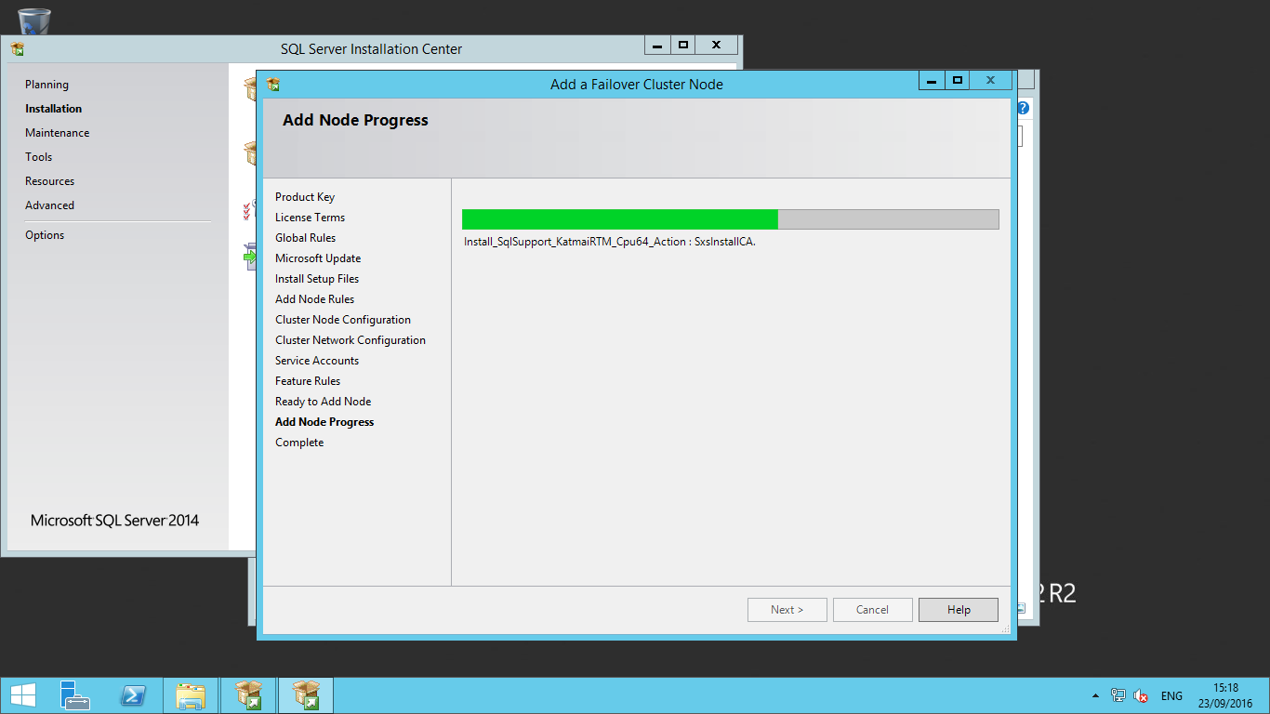

Once installation successfully completes, you will get the below screen with confirmation that all the features you have selected during the SQL Server cluster installation are successful.

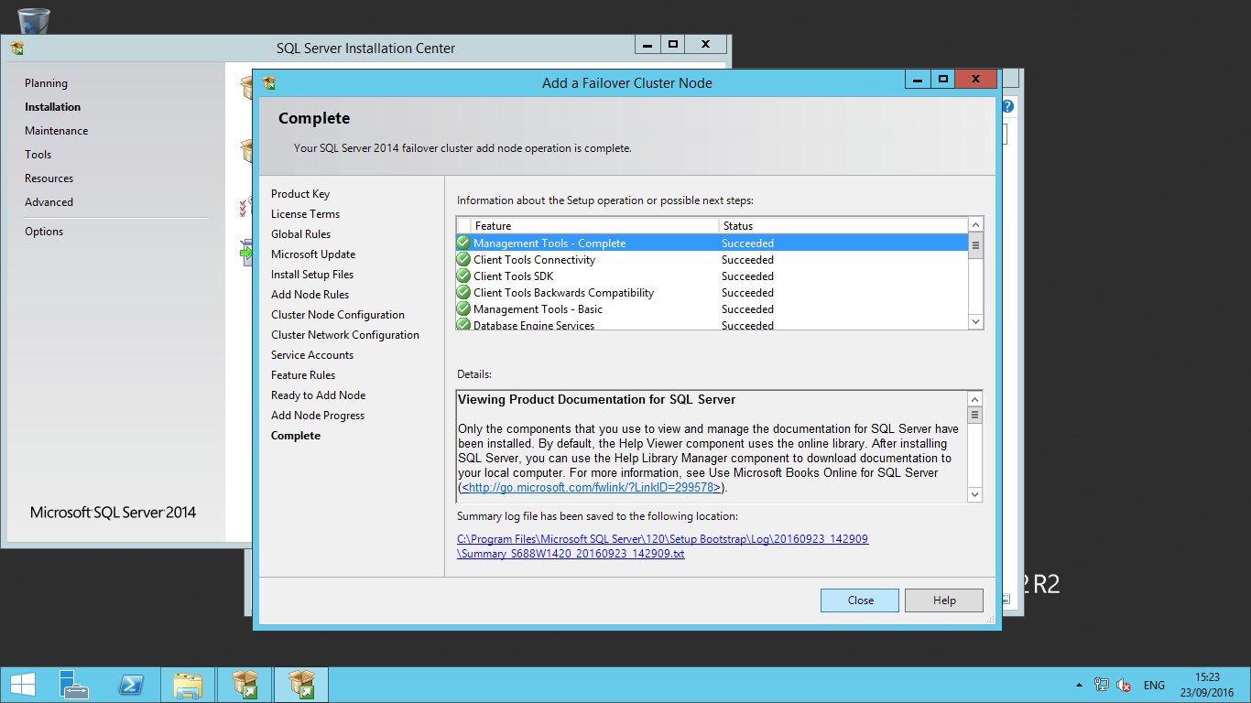

SQL Server failover cluster installation supports Local Disk only for installing the Temp DB files. **Make sure that the path specified for the Temp DB data and log files exists on all the cluster nodes. If the Temp DB directories are not available on the failover target node during failover, the SQL Server resource will fail to come online.** Another advantage of placing Temp DB on a local disk is that it creates separate paths of traffic by having your data and log files on the SAN while Temp DB is on the local disk.